CONFIGURING VM WARE
- Launch your VM WARE workstation

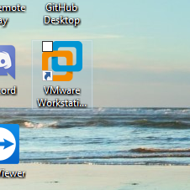

- Power ON all three VMS
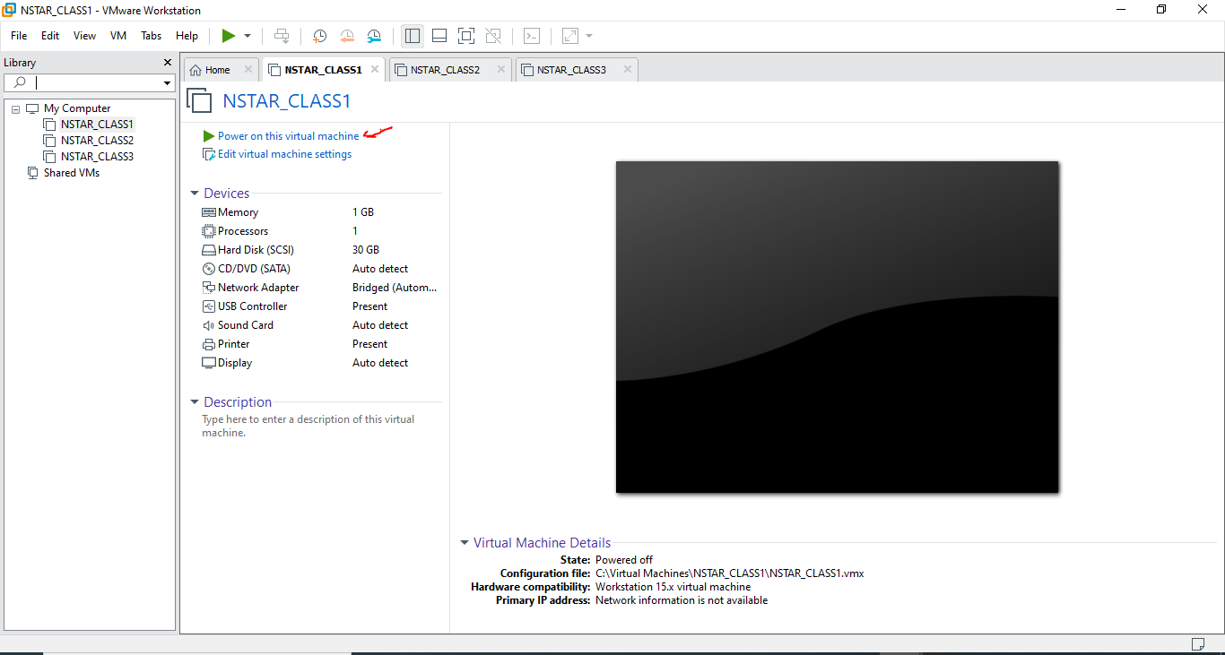

- Click on VM and select (Send Ctrl+Alt+Del)
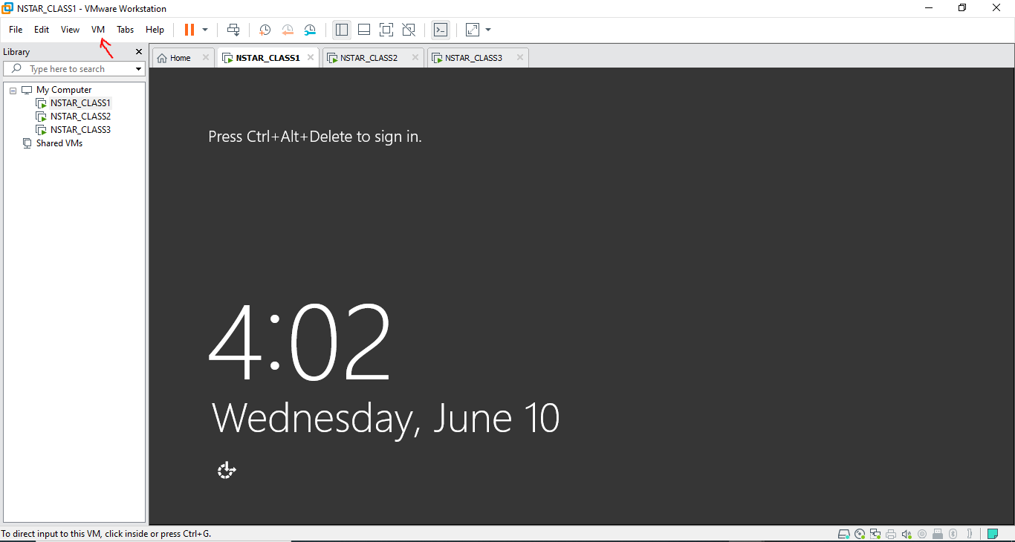

- Input password Next
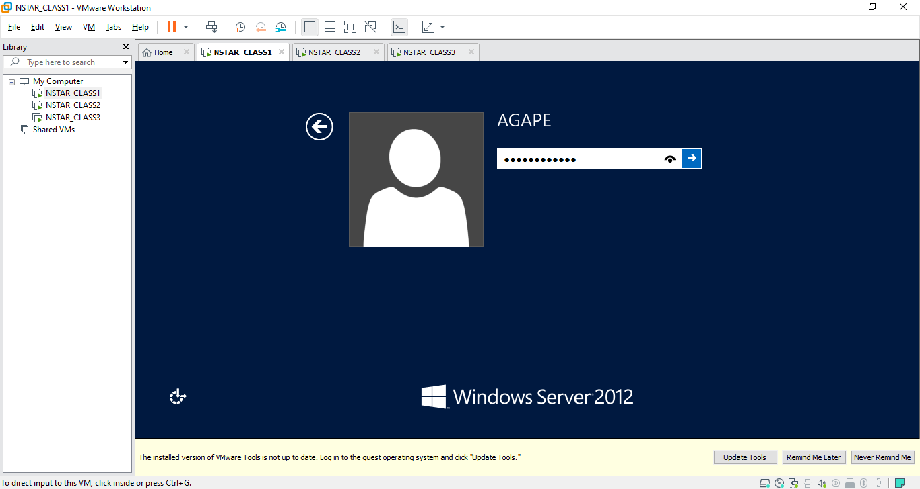

- You can either move your mouse to the edge of the screen until you see your windows icon or click on your VM and hit your windows key on your keyboard.
NOTE: The windows icon isn’t shown on the screenshot but should be visible once your mouse is at the edge
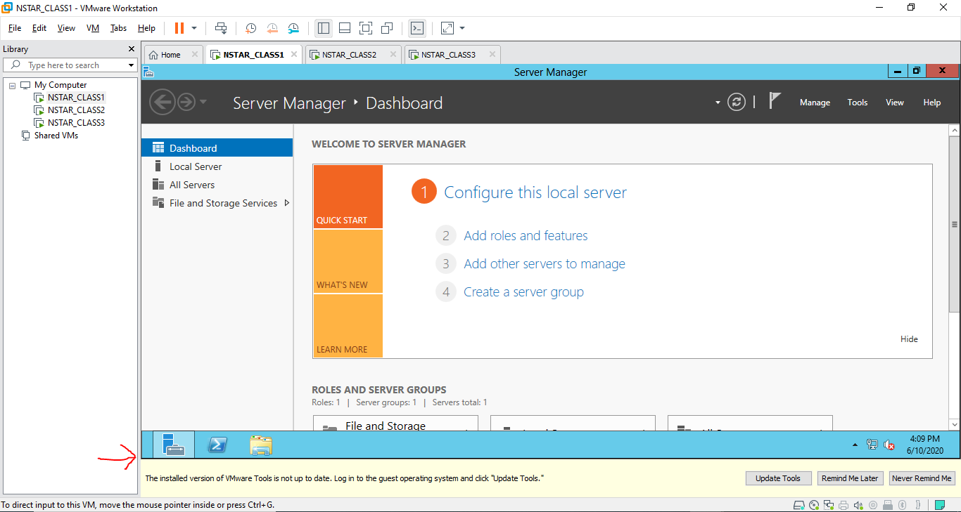

- Next click on control panel
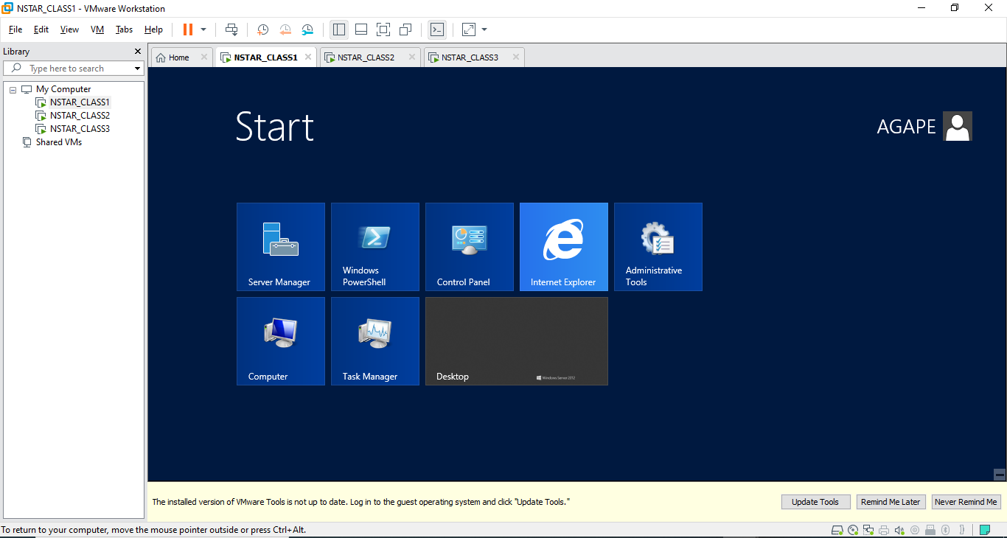

- Go to that path and turn off the firewalls Control Panel\System and Security\Windows Firewall
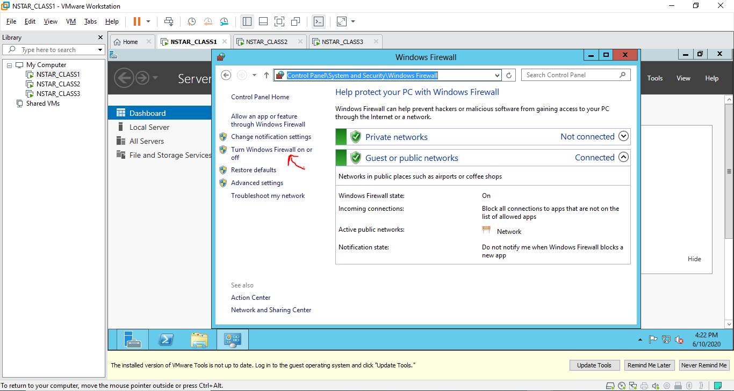
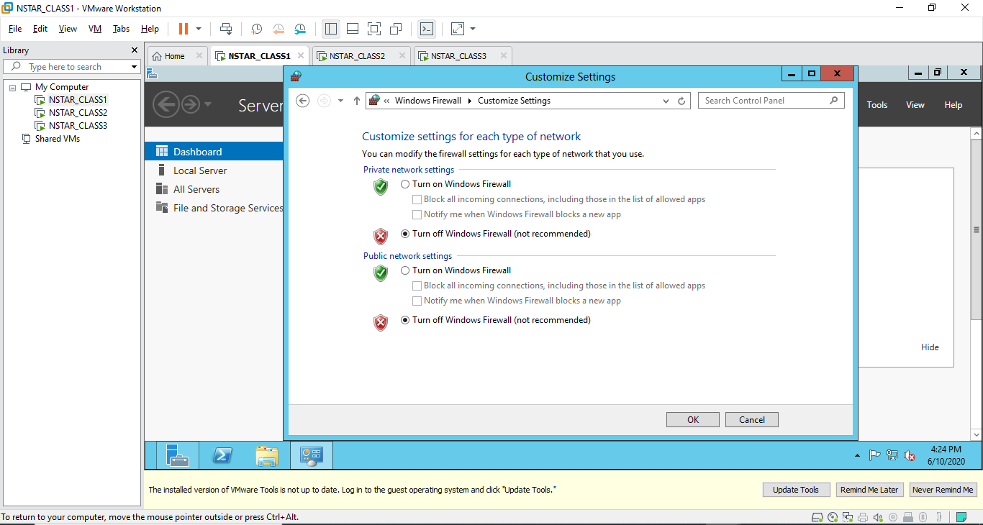
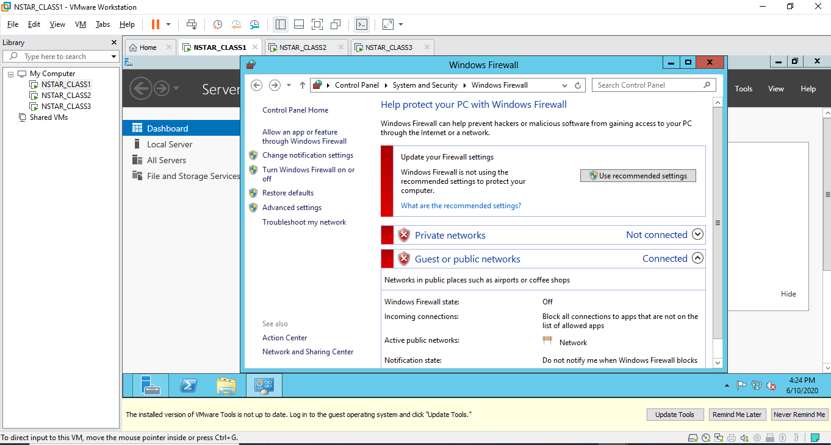

- Next go to that path Control Panel\User Accounts\User Accounts and click Change User Account Control Settings
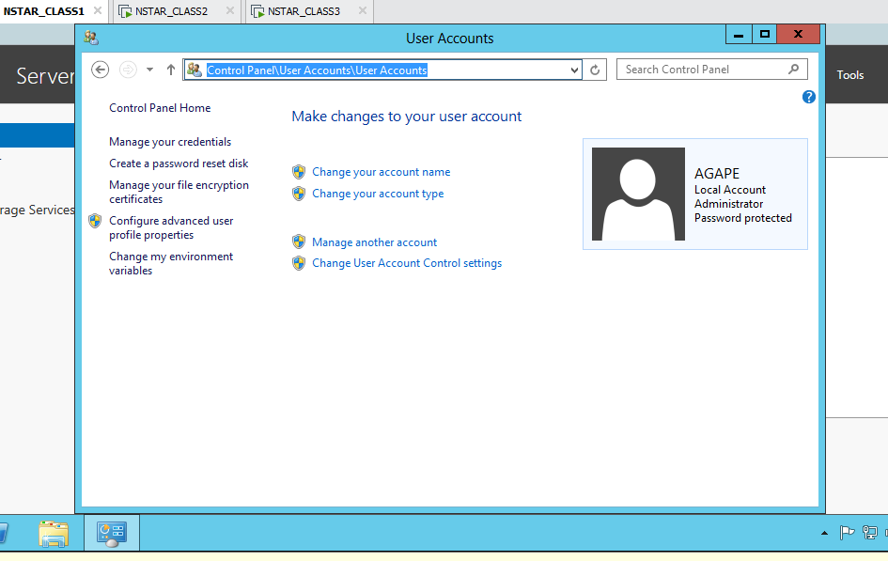

- Pull it all the way down and click ok and YES
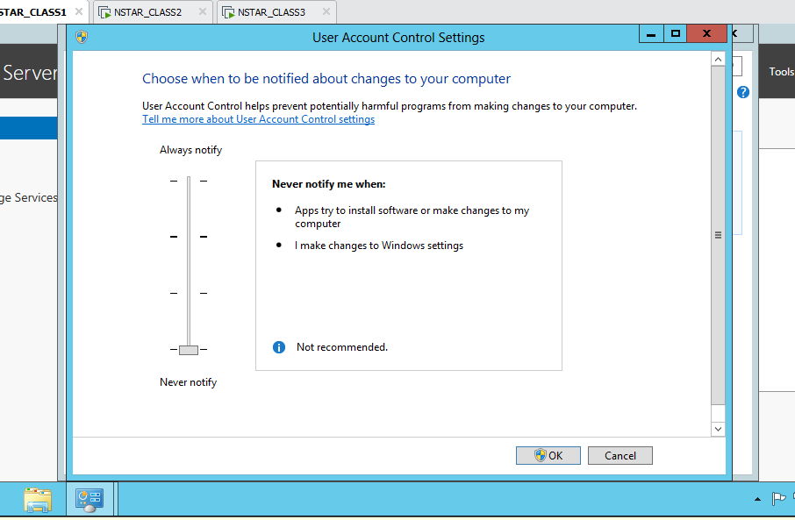

- Next click manage another account
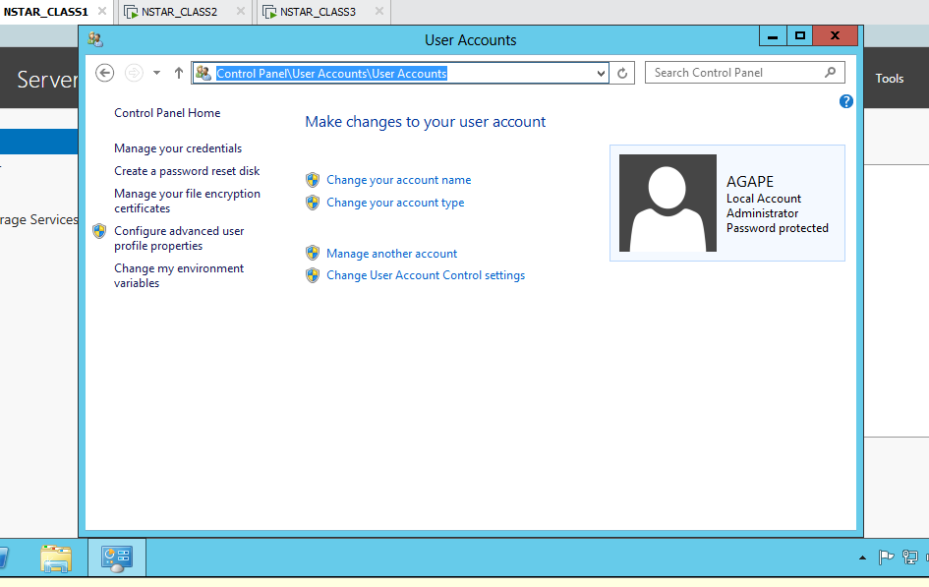
- Next click Administrator
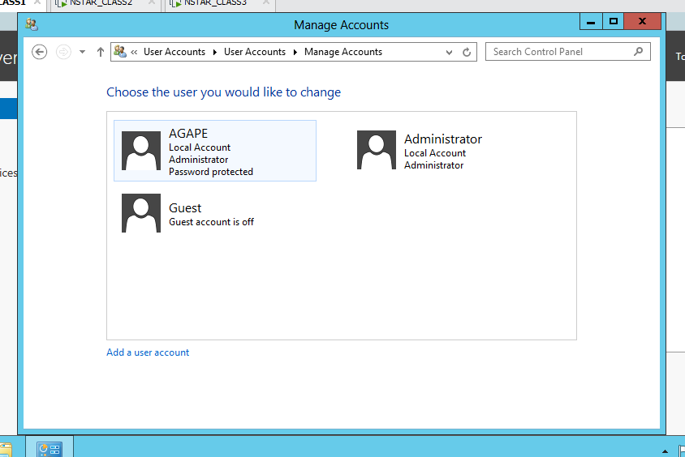

- Next click create a password
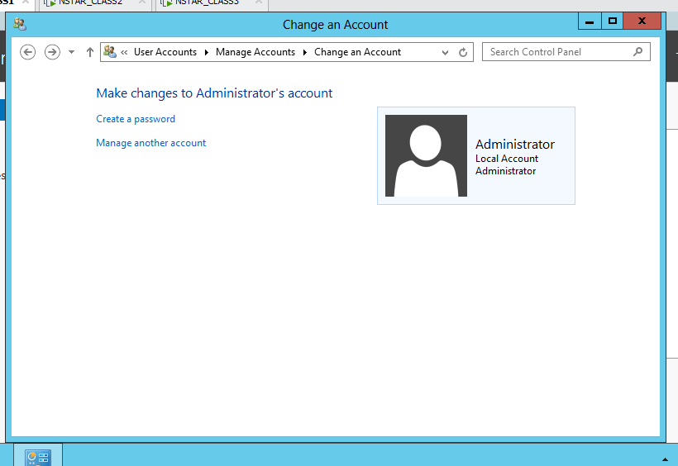

- Input password and click CREATE PASSWORD
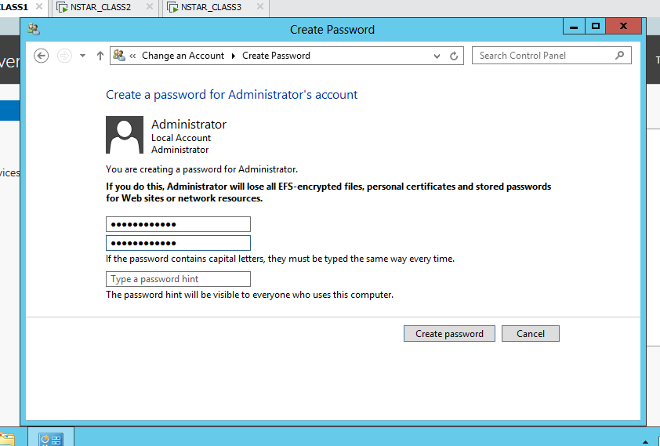

- Next go to this path Control Panel\Network and Internet\Network Connections to configure your IP, click on Ethernet0
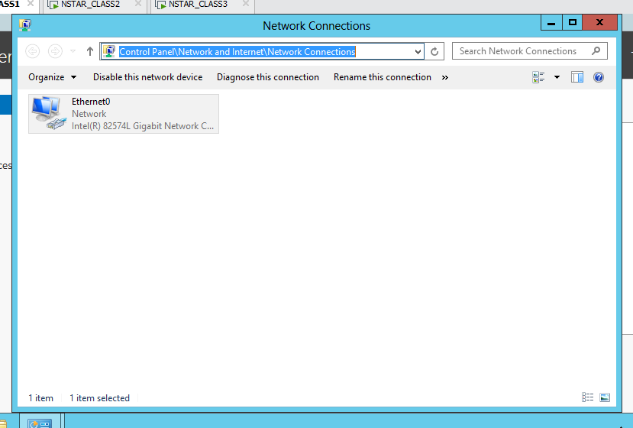
- Click on properties
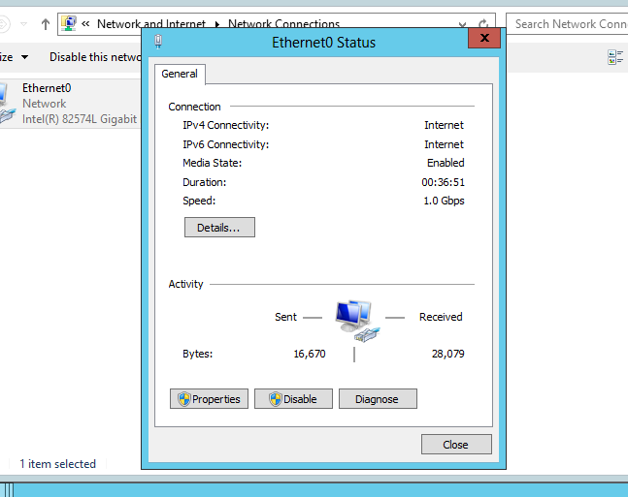

- Scroll to internet protocol version 4 (TCP/IPv4) and click on properties
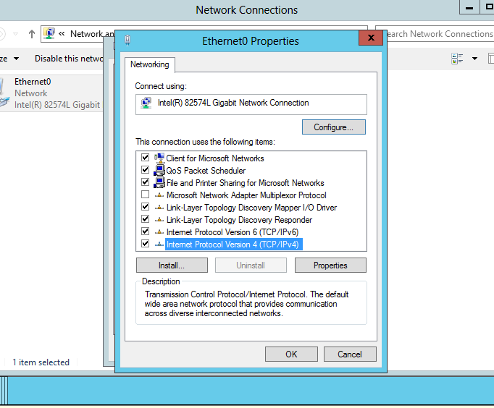
- Populate all lines as shown as click ok
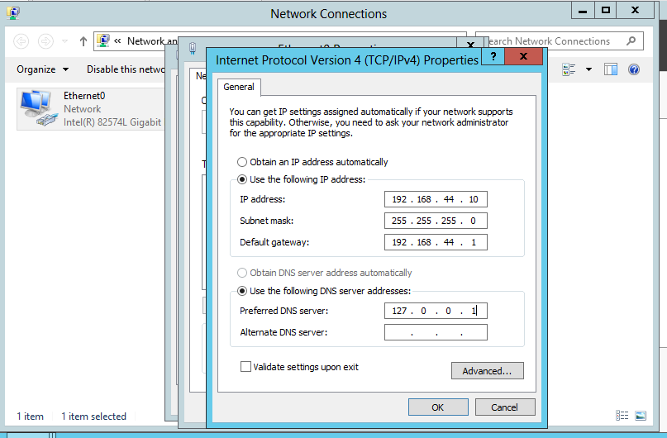

- No repeat 2 – 17 for NSTAR_CLASS2, and NSTAR_CLASS3
- JUST ON NSTAR_CLASS1 make domain controller.

- Click add roles and features
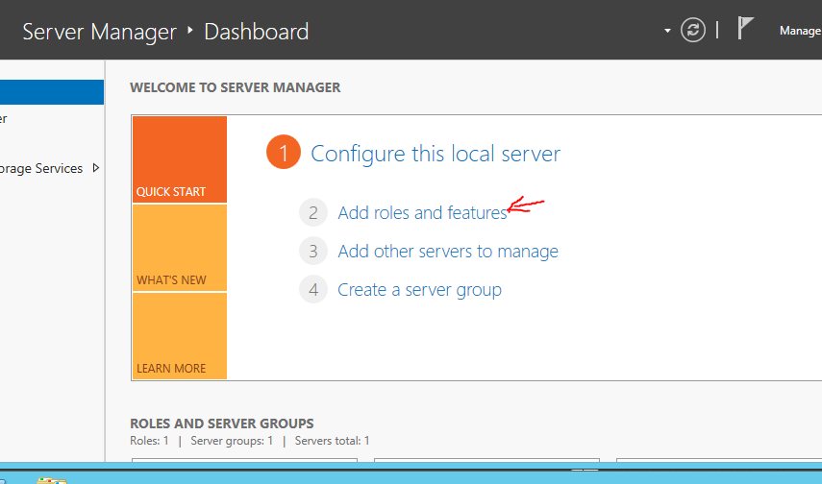
- Click Next 3 times or until you get to this screen
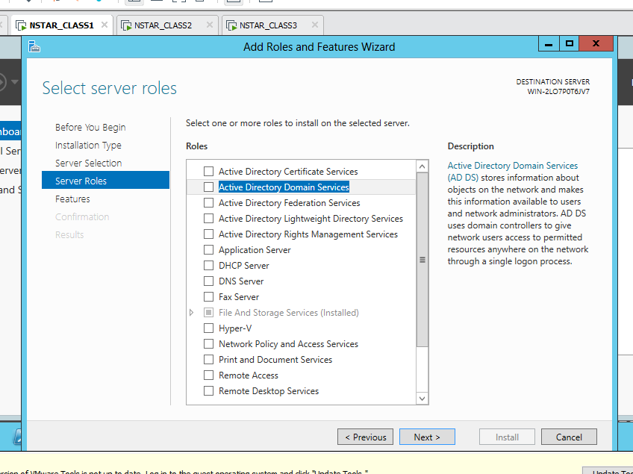

- Select Active directory domain services and click add features and Next 3 times again or until you get to the install screen and click install
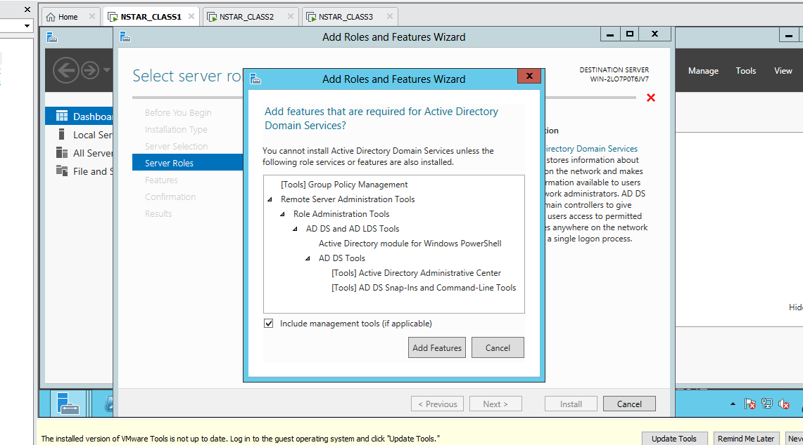
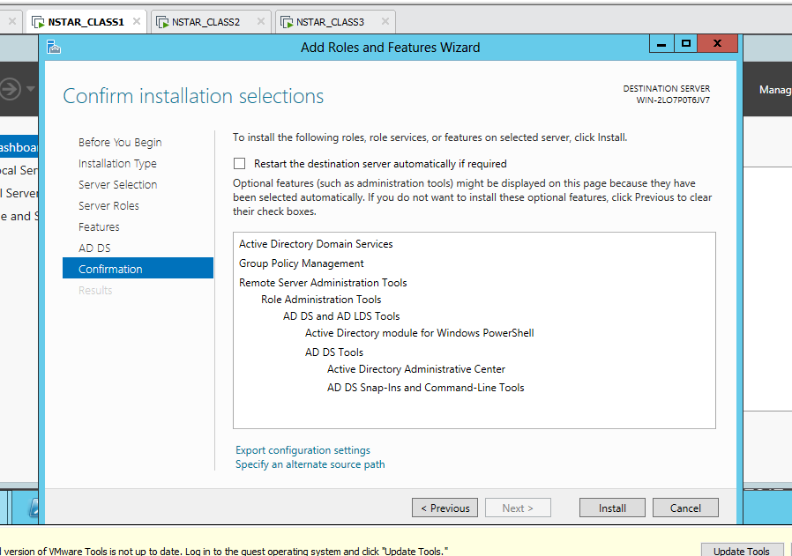
- Next click promote this server to a domain controller
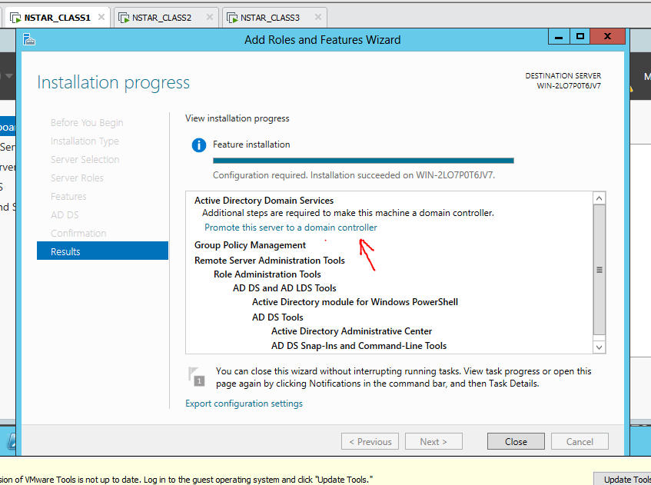
- Select add a new forest, name it and click next
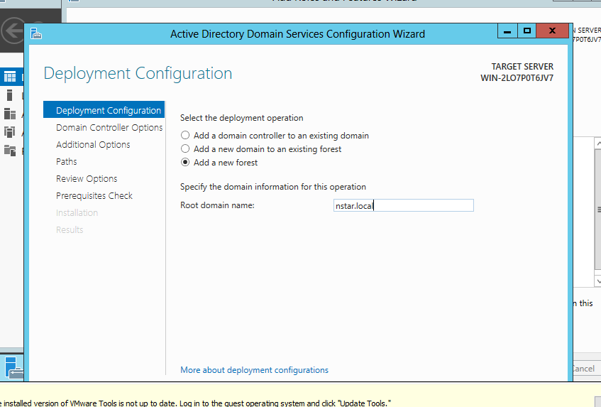

- Specify password and click next
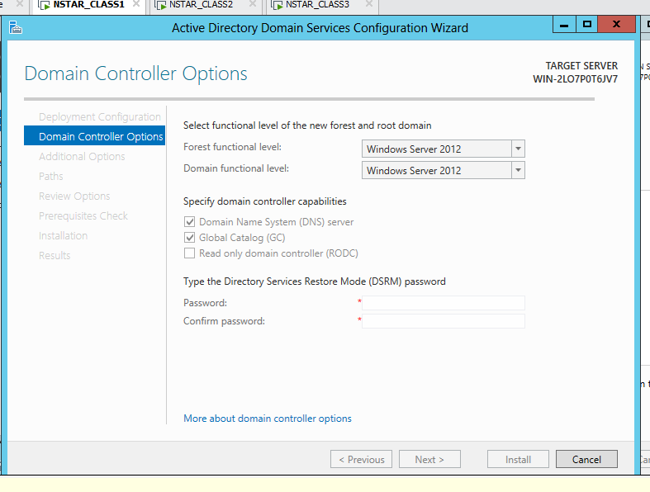
- Click next 4 times or until you get to the installation screen and click install.
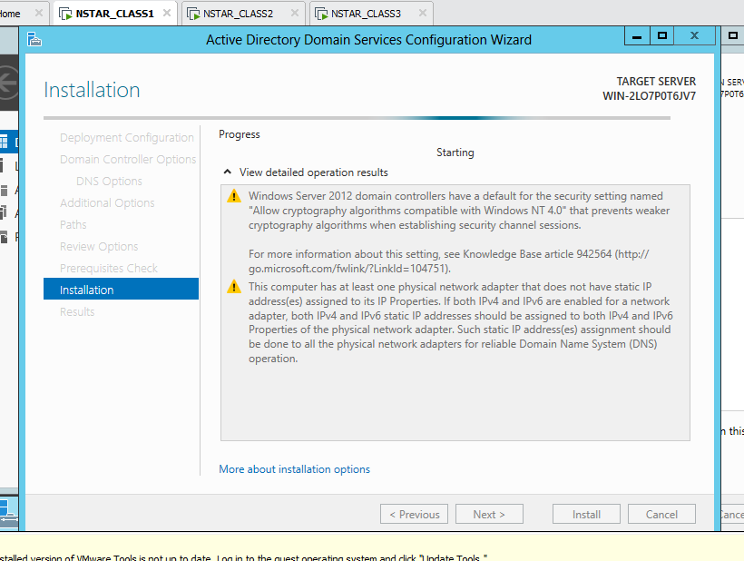

- After installations the domain your VM will restart itself
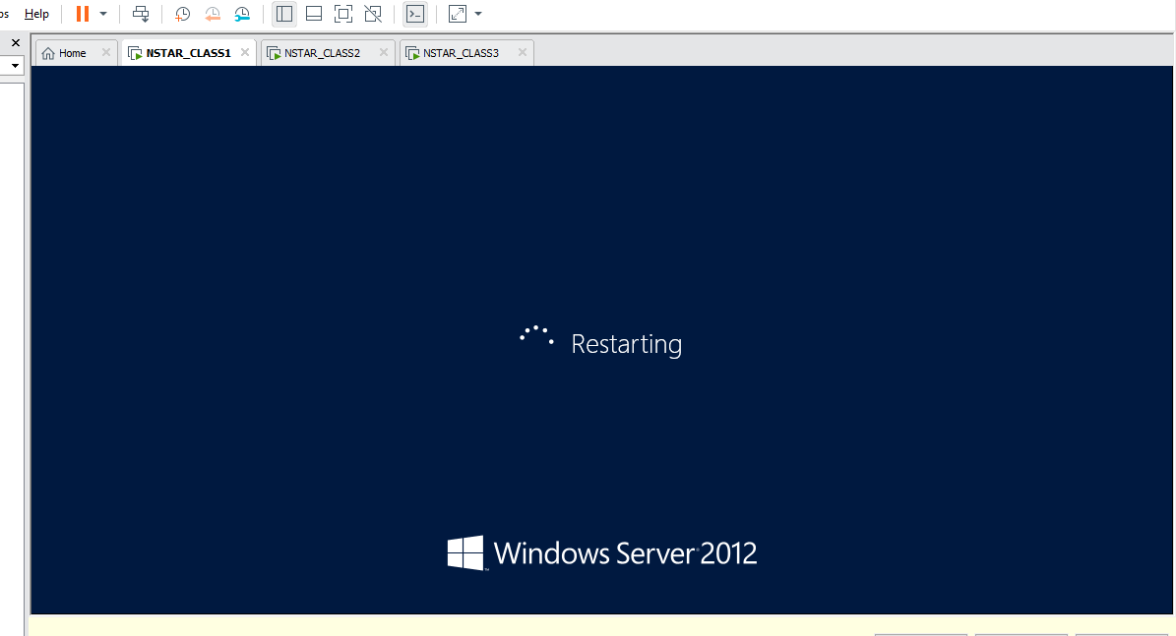
- After VM restart sign into VM again
- NSTAR signifies the creation of a domain, specify your password and sign in
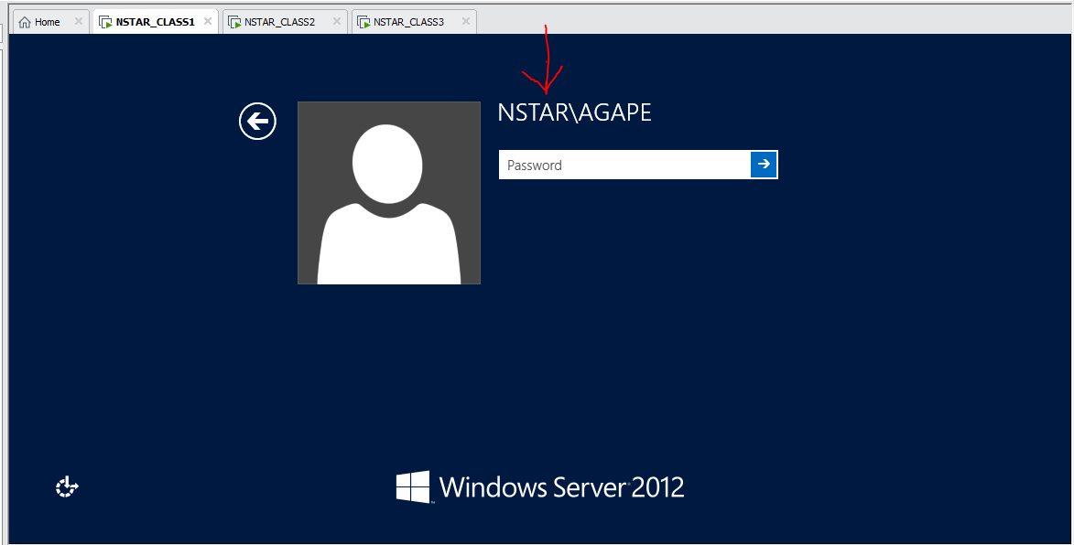

- Now join NSTAR_CLASS 2 and 3 to the domain
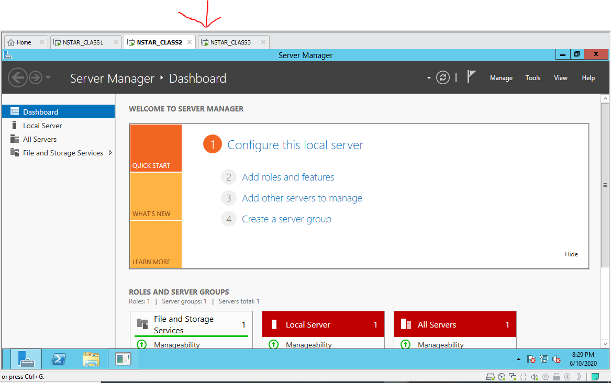

- On NSTAR_CLASS 2 open file explorer, right click on computer and go to properties
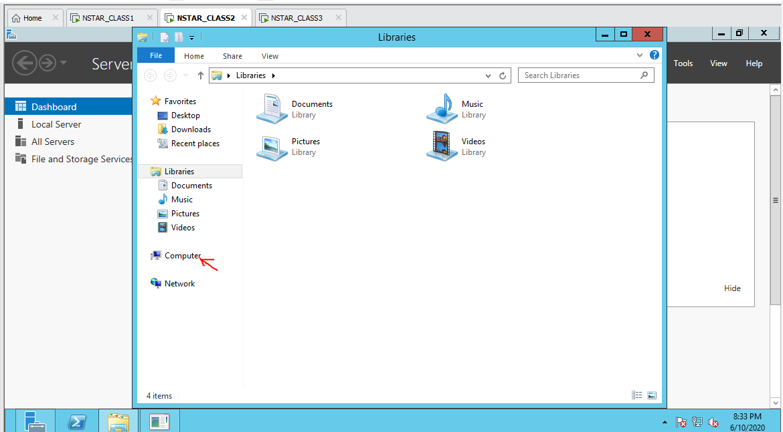
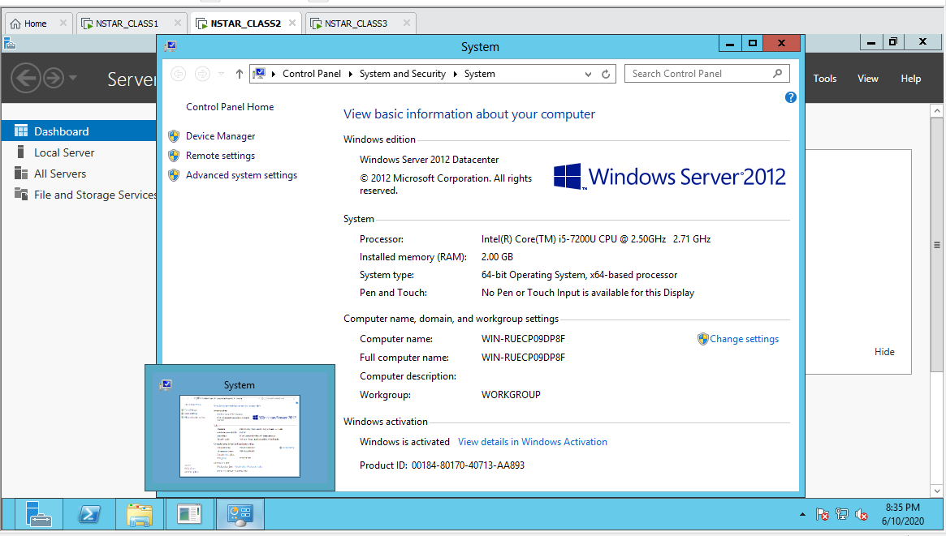

- Click change settings, then click change
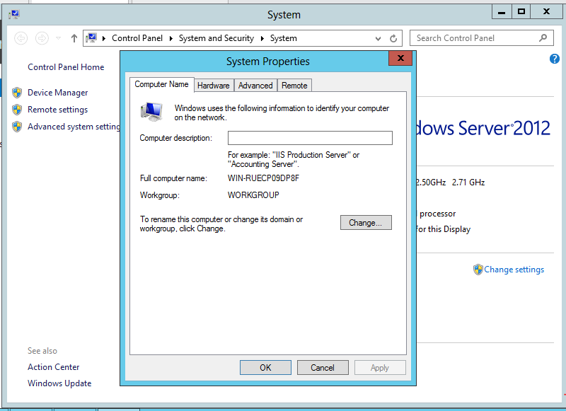

- Name the computer, pick domain and type your domain name and click ok
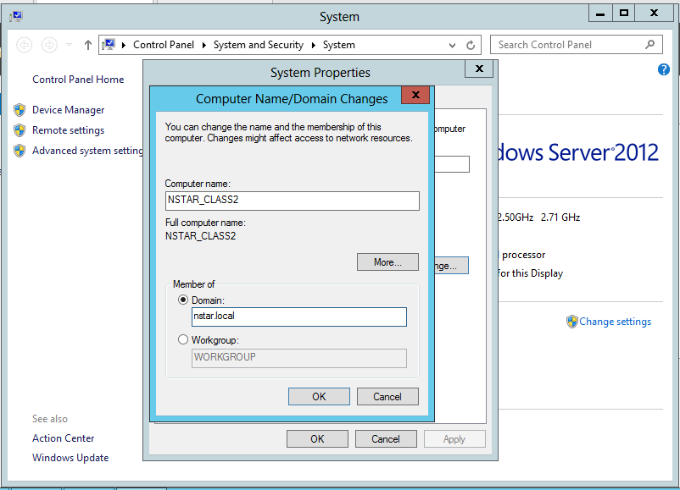
- Click yes
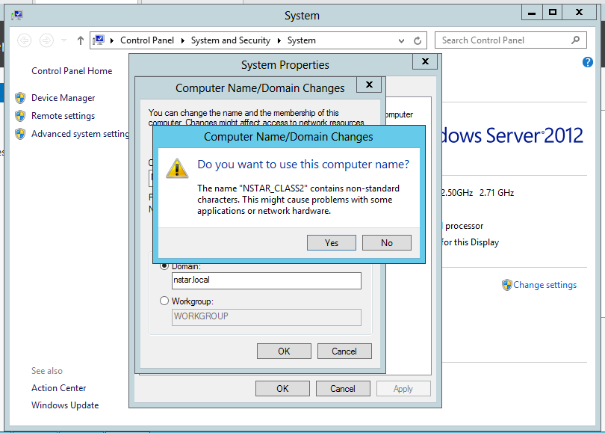
NOTE: DISCONNECTING YOUR WIFI CAN HELP THE VMs IN THIS STAGE

- Type username as Administrator and specify password and click ok
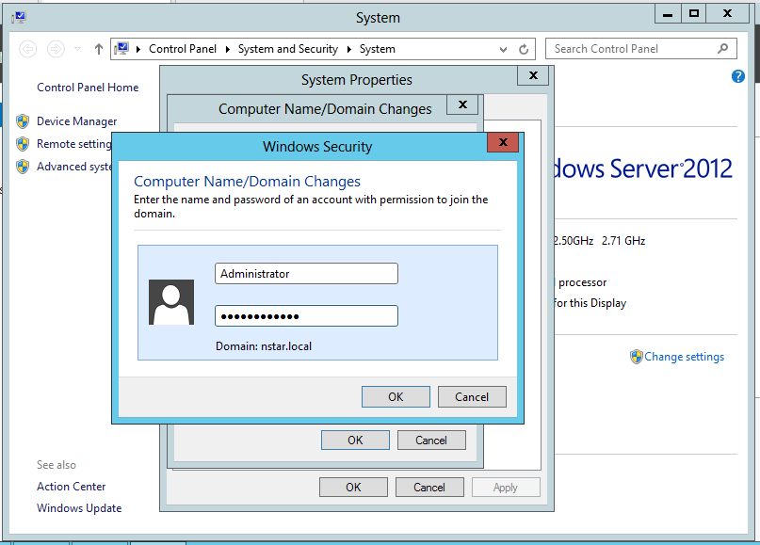
- Click ok, and ok again, close and restart
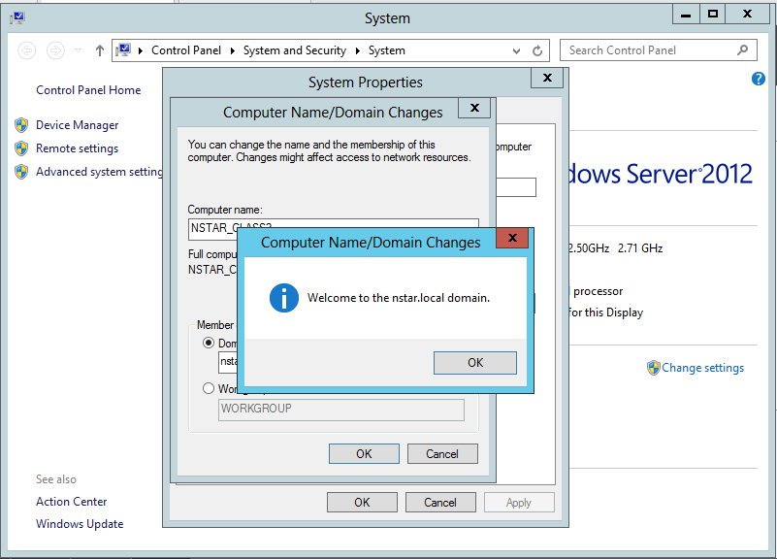
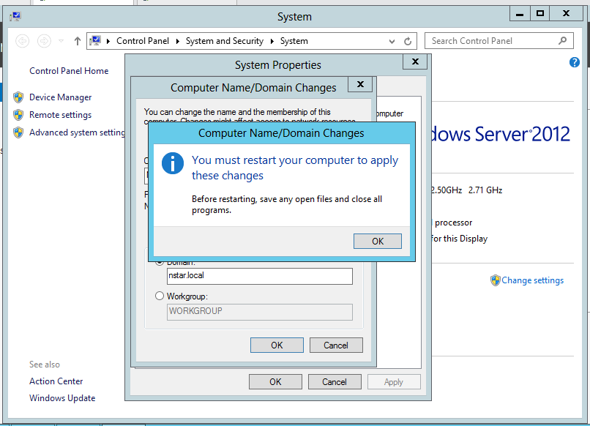
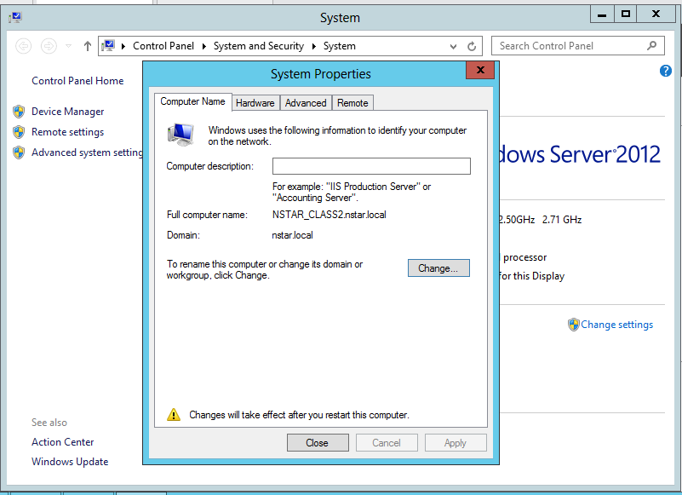
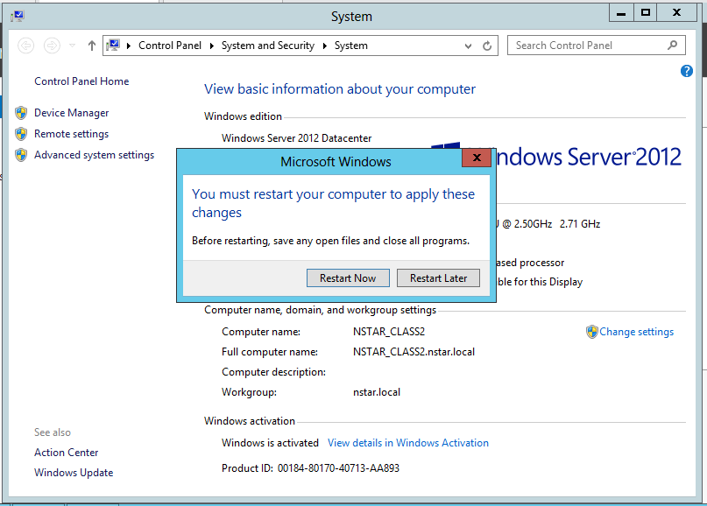

NOTE: REPEAT STEPS 28 to 36 ON NSTAR_CLASS3

- Switch back to NSTAR_CLASS 1
- Go back to your startup window but this time select Active Directory and Users
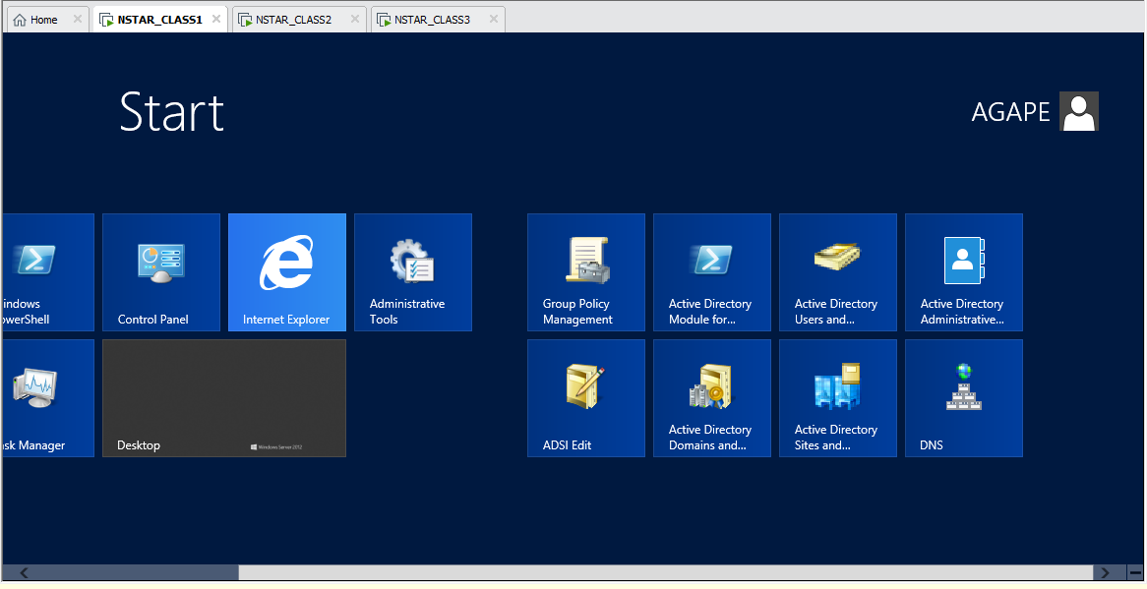

- Click on your domain and click on users
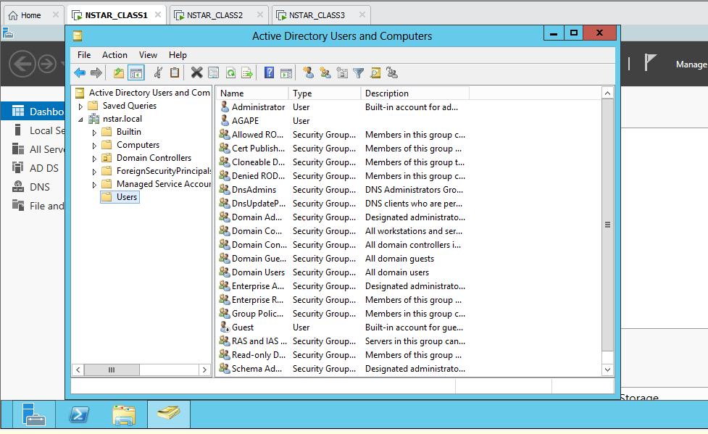

- Right click on users, select new and click on user
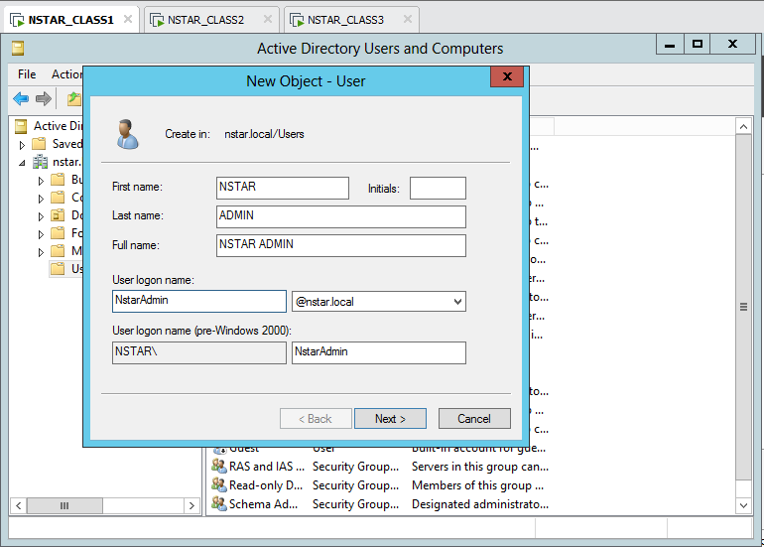

- Select password never expires and specify password, click next and finish
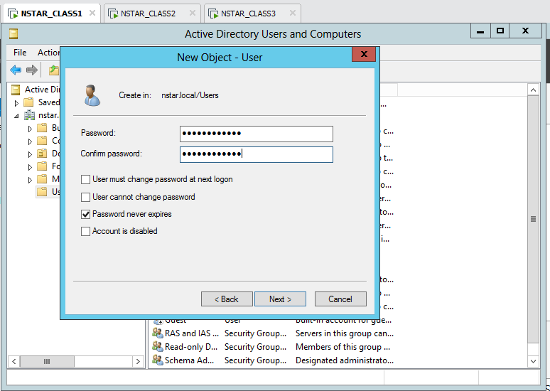

- Create a user called NSTAR SERVICE, logon name will be NstarSvc
- Right click on your users and add to a group
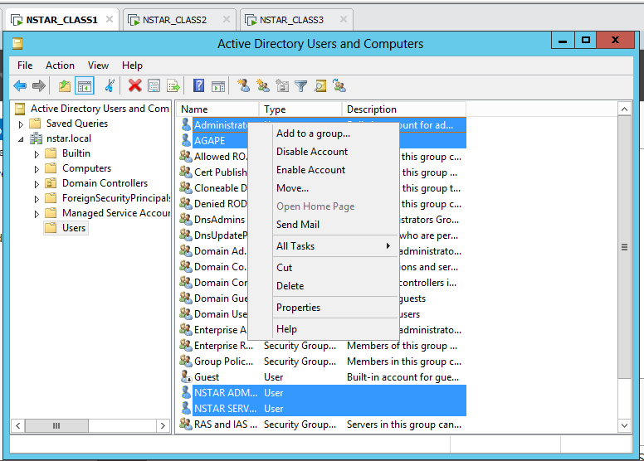

- Type domain and click check names
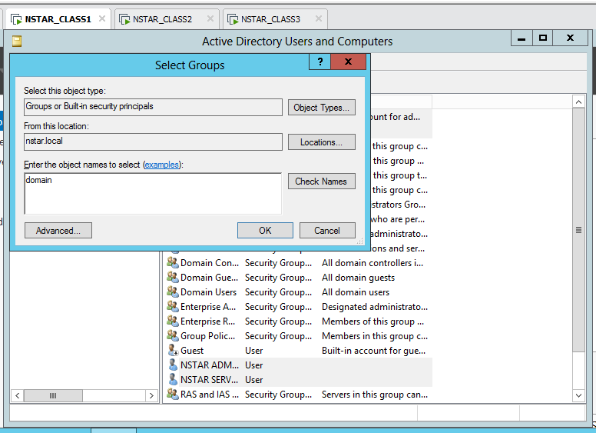

- Click domain admins and click ok, and ok again
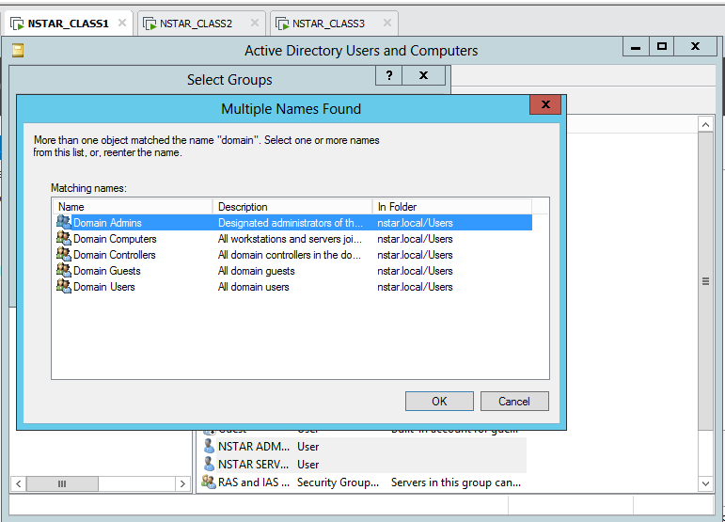
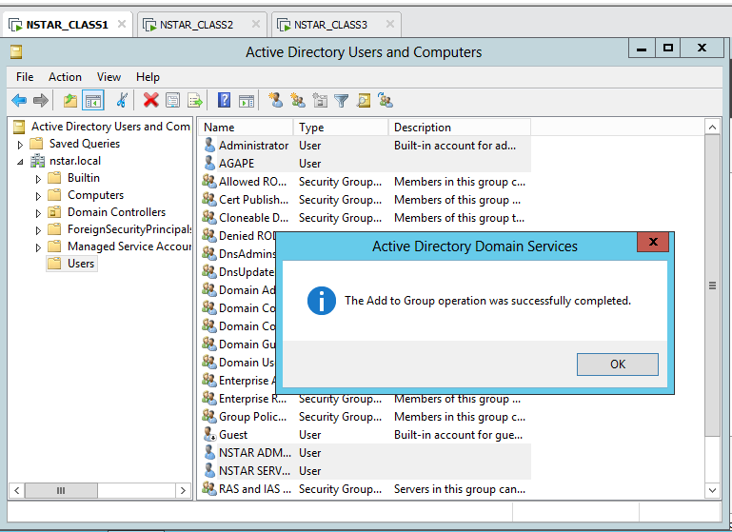

- Sign in NSTAR_CLASS2 and 3 with a user that’s part of the domain
- Click on the back button to use another user
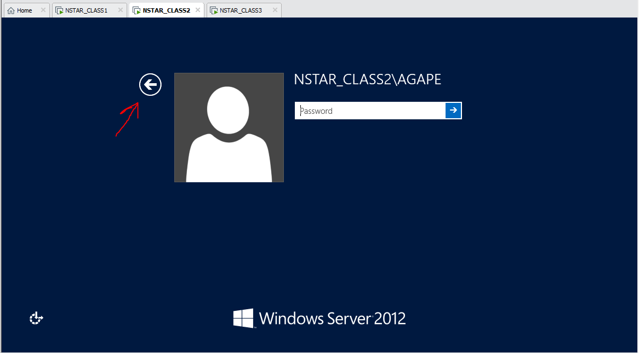

- Click other user
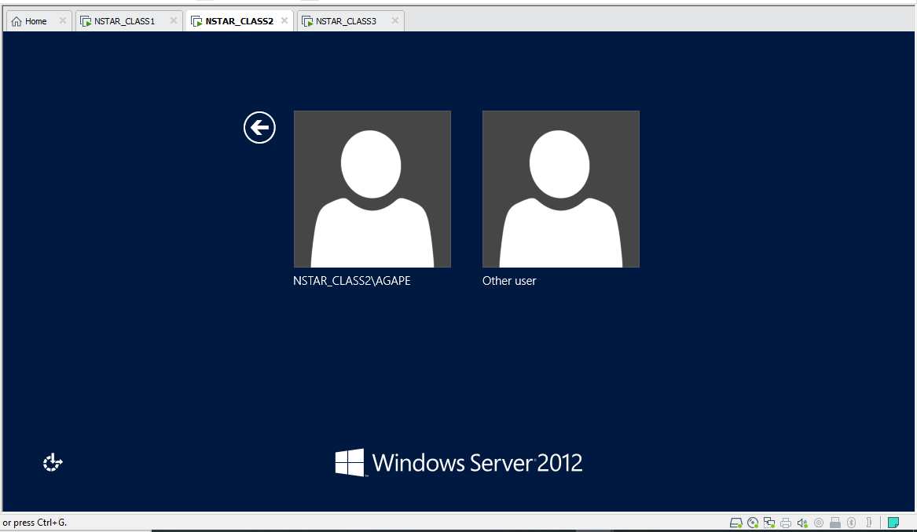

- Type a user in this case NstarAdmin and specify your password
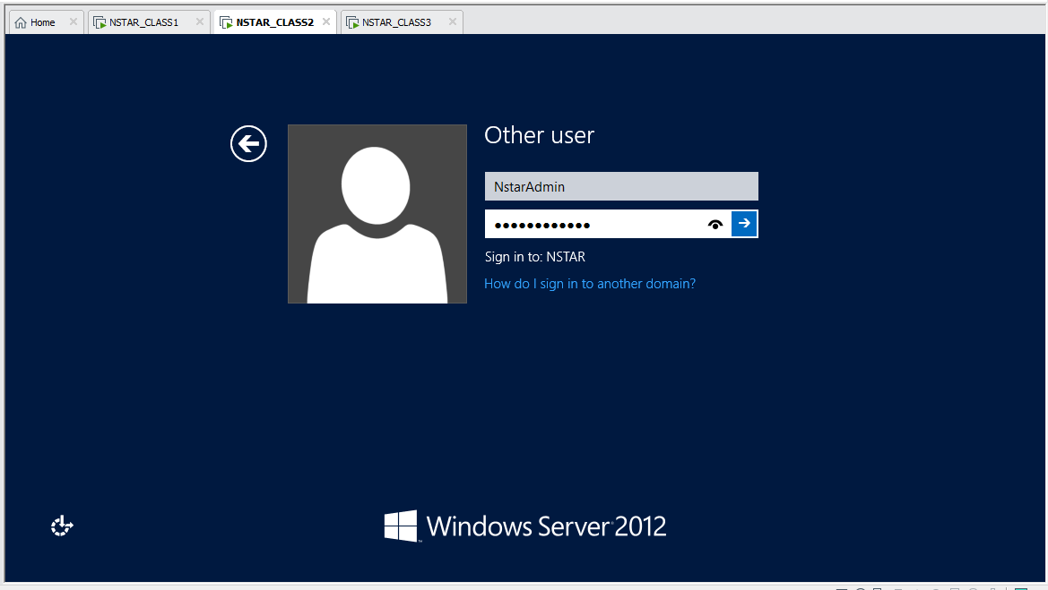

- Click ok, it’ll sign you out and you’ll have to sign back in
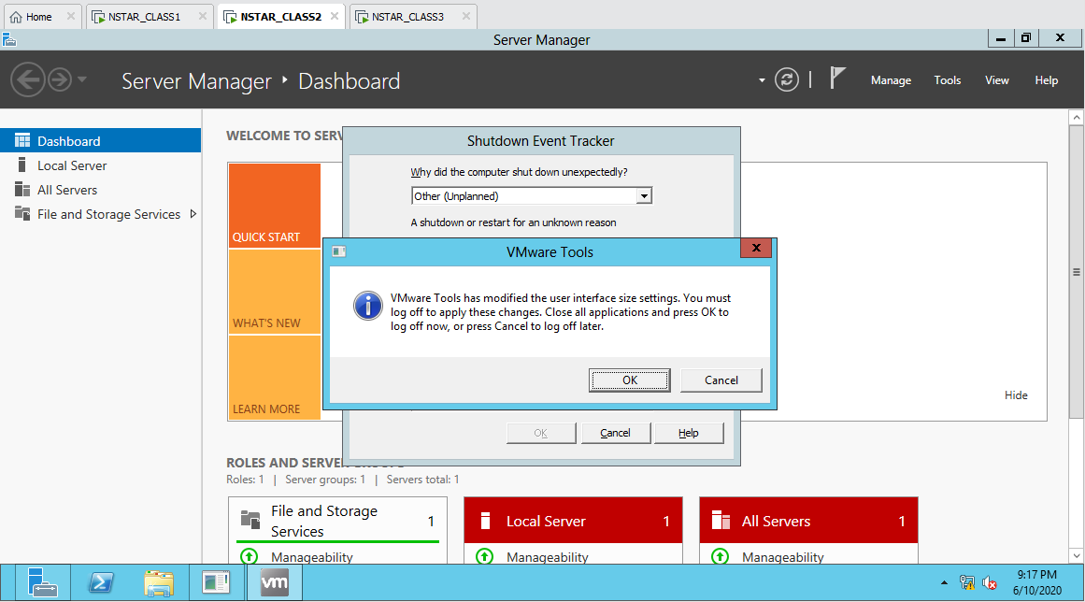

- Now the user is present on selection
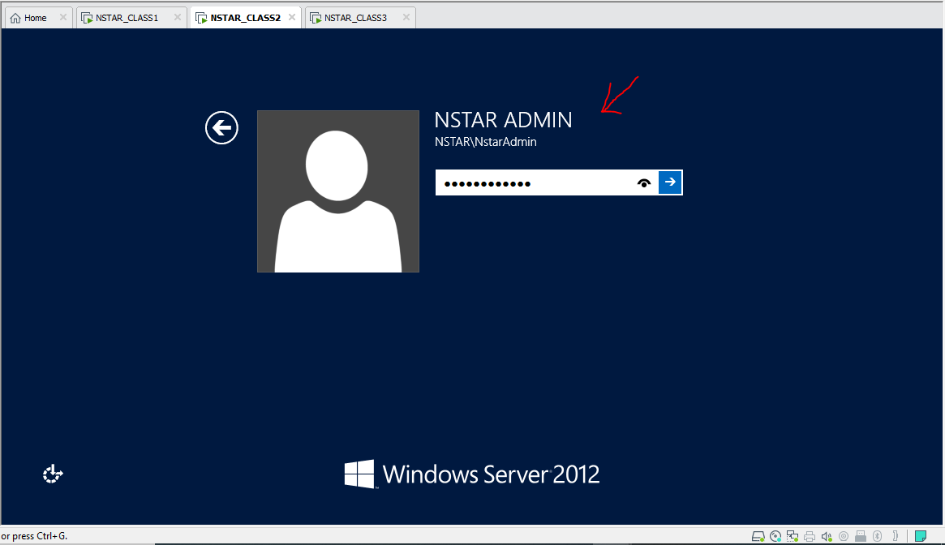

NOTE: REPEAT STEPS 46 to 51 ON NSTAR_CLASS3

